Andrew Taylor-Shaut

Advanced Mobile App Development: Project 1 Milestone 1

Aileen Pierce

10 April 2017

Profile App

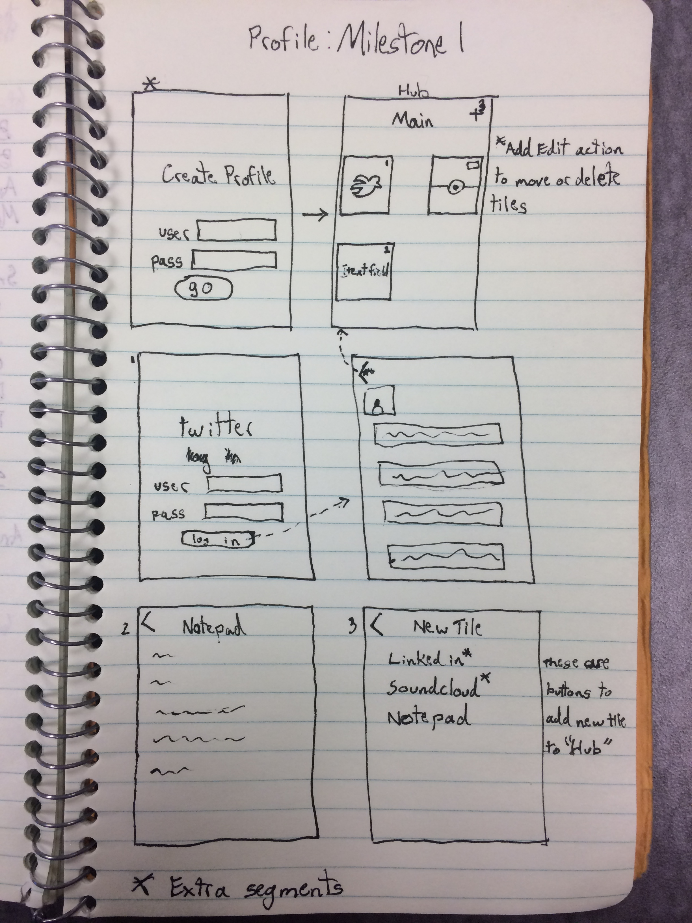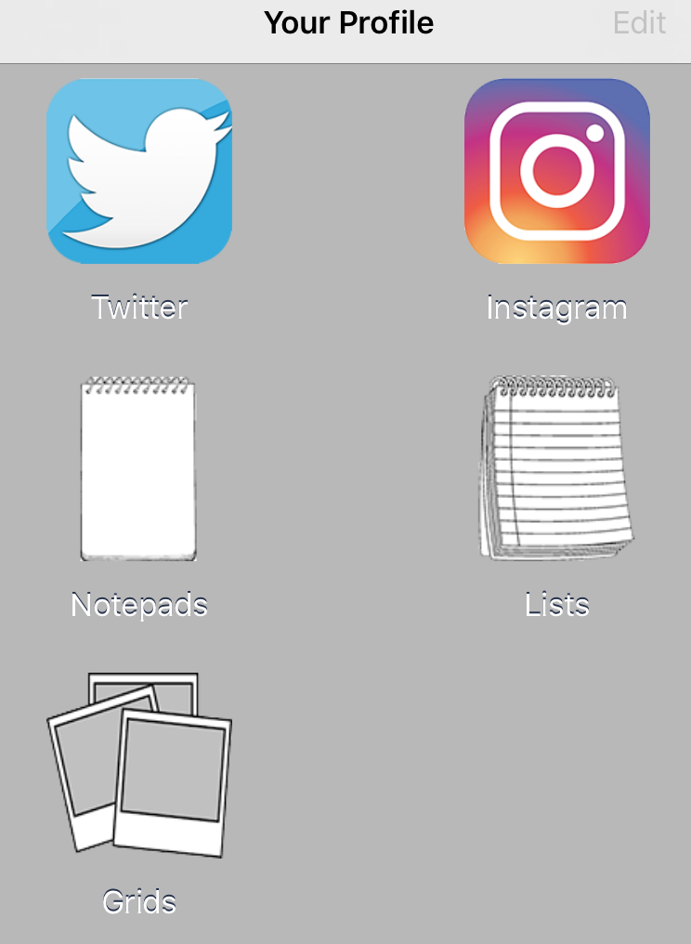 I would like to try and replicate my idea for project 1 in Android format. I want to create a notepad app that has social network functionality. It will have a first page that has multiple images representing different options for people to choose from. Since we have not gone over much of the functionality that I would try to incorporate, I will set the bar at getting one page that is a list of text fields or editable lists (like in my project 1) that the user has created as well as having the next page with persistent data of those text fields. Further goals for this app would be trying to get the first page to be a collection of image buttons like a collection view on iOS, save the data to a firebase network, connect to a person’s social network feed, and to see how much functionality I can get working beyond the base goal. This app will allow the user to store their profiles as well as other information they want one this collection of information. The intended audience is artists and creative types who have multiple social networks that have multiple different aspects of the user’s life and that may not have the proper functionality to share all their work on.